# Crowdsourcing a SuperCoach Starting Squad

*Steven Edwards is a PhD Candidate in the School of Mathematics at Monash University who works on large-scale optimisation problems.*

## Embracing the Wisdom of Crowds

The “*wisdom of crowds”* is a concept at the junction of economics and psychology with the underlying principle that in some circumstances groups as a whole can often be smarter than the smartest people in the group.

The notion that the judgement of a crowd can be surprisingly accurate is generally traced back to an observation made by Charles Darwin’s half cousin Francis Galton in 1907. At a country fair, Galton observed that the average of the almost 800 entries in a ‘guess the weight of an ox’ competition was alarmingly accurate – predicting the weight of the ox to the exact pound. Talk about a win for the people.

In SuperCoach it is possible to see how popular a player is by looking at their percentage ownership. It is generally an accepted strategy that you do not want to have too many players with a high percentage ownership otherwise there will likely be other teams that are very similar to yours and reduce the chance that you win overall. This results in coaches searching for players with low percentage ownership who, in their opinion, are underestimated. These players give the team a point of difference and as such these types of players are referred to as PODs for short.

But what if instead of searching for PODs you were to do the exact opposite? Embrace the wisdom of the crowd and pick your starting squad to maximise percentage ownership. That is the starting strategy for my AI team, BOTempelli, this year. The squad below is the team that optimally maximises the percentage ownership based on data from March 2nd.

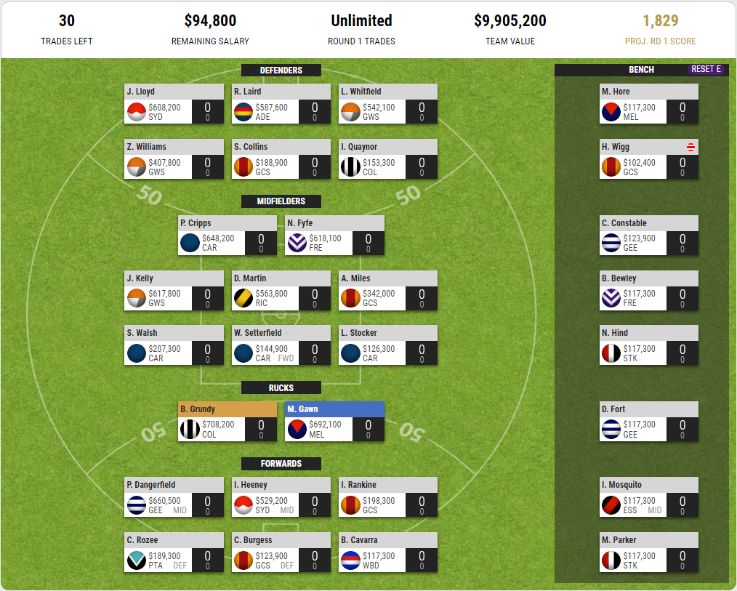

Anyone who has already been doing some research for the 2019 season will be quick to point out that this team is very generic. But that is exactly the goal. The team is in fact as generic as possible.

## Defence

The backline is stacked with Lloyd, Laird, and Whitfield as well as the popular mid-price option Zac Williams, who is returning at a discounted price after missing most of the 2018 season with an Achilles injury.

The rookie options also seem solid. Sam Collins is the 24 year old ex-fremantle player who was third in the 2018 VFL best and fairest. Isaac Quaynor, a solidly built Under 18 All-Australian defender, won the goal kicking test at the 2018 Draft Combine with a perfect score. Marty Hore is a 23 year old back-to-back best and fairest winner for Collingwood’s VFL side.

Unfortunately though the crowd has selected Harrison Wigg, the injury riddled talent at the Suns who after repeat ankle injuries has a couple of weeks ago ruptured his ACL. If you have Wigg in your squad could you do me a favour and trade him out? Thanks.

## Midfield

Midfield premiums include Cripps, Fyfe, Kelly and Dusty Martin. Again there is a popular mid-price option in Anthony Miles, former 50 game player at Richmond and winner of the 2018 VFL best and fairest.

The midfield includes a very risky six rookies including three from Carlton. Sam Walsh is the classy number 1 pick in the 2018 AFL draft. Liam Stocker won the best and fairest is last year’s TAC cup. Will Setterfield is a much hyped prospect who joins the blues after missing the entire 2018 season at GWS with a ruptured ACL.

The remaining three rookies are Charlie Constable, the versatile 191cm running midfielder, Brett Bewley, the 23 year old outside mid who was named in consecutive VFL teams of the year, and Nicholas Hind, the 24 year old who should almost be picked purely based on his [sprint down the middle of the ground](https://www.heraldsun.com.au/leader/news/7vfl-richmond-v-essendon-winning-goal-facebookfbdownnet/video/083acdb64a556317f57e2f9d92ca367b) in the final 10 minutes of the come from behind win in Essendon’s VFL semi-final last year. Although quite aggressive with so many rookies this seems like a reasonably strong midfield.

## Rucks

The rucks have both Grundy and Gawn, the two most expensive players in the whole competition not including the injured Tom Mitchell.

The rookie option in the rucks is Darcy Fort, the 25 year old who quit his job as a civil engineer to return home to Geelong. However behind Rhys Stanley, Zac Smith, and Ryan Abbot, it looks like Fort has a bit of work to do to break into the senior side.

## Forwards

At this stage the forward line is somewhat terrifying containing only two premiums and a total of six rookies. Dangerfield and Heeney are both very popular options this year and for good reason. After that though it becomes more challenging.

Three of the rookies appear to be solid condidates. Izak Rankine has been playing in the SANFL since he was 16 years old and was named in the under 18 All-Australian team twice. In addition, at the Draft Combine Rankine won the agility test and came third in the 20m sprint.

Ben Cavarra is a small forward who was in back-to-back VFL teams of the year and a prior Morrish Medalist as the best player in the TAC cup.

Matt Parker is an explosive forward from South Fremantle, who after enduring a supposedly troubled youth and bursting into tears upon hearing his name be called out at this year’s draft looks hungry to pay back St Kilda for their faith in him.

The other three rookies that, in my opinion, have somewhat more uncertainty are Connor Rozee, pick 5 at the AFL draft, Chris Burgess, the 23 year old contested marking defender, and Irving Mosquito, who is a very exciting prospect but at 18 years old will also be completing Year 12 and so it might be too much to expect him to consistently feature in Essendon’s senior side.

## Dual Position Players

The crowd is currently selecting a very aggressive guns and rookie approach. The massive total o 18 rookies is making me a little bit nervous. The team is also somewhat rigid. In terms of dual position players the only real flexibility comes from Setterfield in the midfield who could be swung forward in exchange for Dangerfield, Heeney or Mosquito.

It would also be nice if either Rozee or Burgess were selected in defence so that they could be swung between lines to cover holes. Hopefully when the crowd eventually trades out Wigg this might naturally correct itself. With so many rookies and such little flexibility I am currently concerned for BOTempelli’s prospects.

## Should this work?

So should this work? In his book “the Wisdom of Crowds” James Surowiecki proposes four criteria that separate wise crowds from irrational ones, three of which in my SuperCoach appears to satisfy.

The first criteria is ‘Diversity of Opinion’ – each person has their own interpretation of the facts. For example I might think Patrick Cripps is god’s gift to football but you might mistakenly think he’s overrated.

The second criteria is ‘Decentralisation’ – people have access to draw on their own local knowledge. I believe this to be true for SuperCoach as everyone has that friend of a friend of friend who knows someone at the club who confident claims that, for example, Bailey Scott will definitely be picked for North Melbourne in round 1.

The third criteria is ‘Aggregation’ – there must exist some mechanism for turning private judgements into a collective decision. This is what BOTempelli aims at doing by using percentage ownership to determine the most ‘average’ team.

The final criteria, and the criteria that I believe might drop the ball so to speak, is “Independence” – people’s opinions are not to be influenced by the opinions of those around them. In SuperCoach there is so much information to stay on top of that often many coaches rely on experts in the forms of blogs, podcasts, and news articles like this one. This can result in somewhat of a herd mentality as many teams can be drawn to a small number of players.

Even writing this article is likely being counterproductive to the wisdom of the crowd by bringing everyone’s attention to a subset of the players, propagating their already high popularity. So I (very selfishly) encourage everyone this season to back their own judgement, do their own research and in doing so help improve the intelligence of the SuperCoach crowd and my chances of glory.